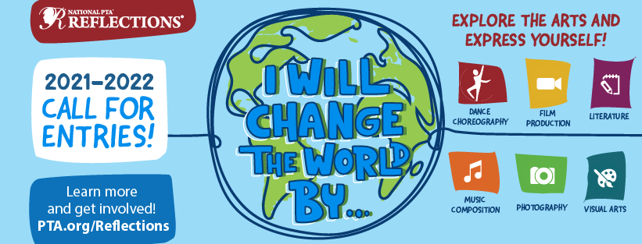

2021-2022
OHIO PTA’s OFFICIAL RULES

Ohio PTA
40 Northwoods Blvd, Suite A
Columbus, Ohio 43235
(614) 781-6344 or (800) 699-6628
(614) 781-6349 Fax
office@ohiopta.org
www.ohiopta.org

IMPORTANT INFORMATION
To be eligible for the Reflections Program your PTA must have sent in and paid its first installment of dues to the Ohio PTA office by
NOVEMBER 30, 2021

Deadline for all entries to Ohio PTA is
WEDNESDAY, JANUARY 12, 2022 by 4:30 P.M.

PACKETS on the Reflections tab of the Ohio PTA website
www.ohiopta.org
Important paperwork and instructions located in OHIO PTA’S OFFICAL RULES
Ohio PTA’s Official Rules
- REFLECTIONS 2021-2022 Official Rules
- General Unit and Council Participation Rules
- Guide to Online Registration
- MANDATORY Official Ohio PTA Participation Form
- Student Participation Information and Official Rules
- MANDATORY 2021-2022 Student Entry Form
LOCAL LEADER’S GUIDE – Information to help develop and run your local programs
- Getting Started
- Promote Your Program
- Coordinate Review of Student Submissions
- Celebrate Your Student Participants
- Wrap Up and Report Program Success

STUDENT PACKET – Important Information and Mandatory Student Entry Form

7
RETURN OF STUDENT PIECES
- Ohio PTA Awards include Award of Excellence, Award of Outstanding Achievement, Award of Merit and Honorable Mention in each age category for Visual Arts, Literature, Dance Choreography, Video Production, Musical Composition, Photography and Special Artist.
- Ohio PTA’s Visual and Photography entries are returned to the local units, except for those that are selected by Ohio PTA. Check with your District Advisor for specific return dates. The winning entries will be returned at a later date. Literature, Video Production, Music Composition and Dance Choreography entries will not be returned.
- Ohio PTA exhibits the winning entries at the annual Ohio PTA convention and at various locations when available during May-October.

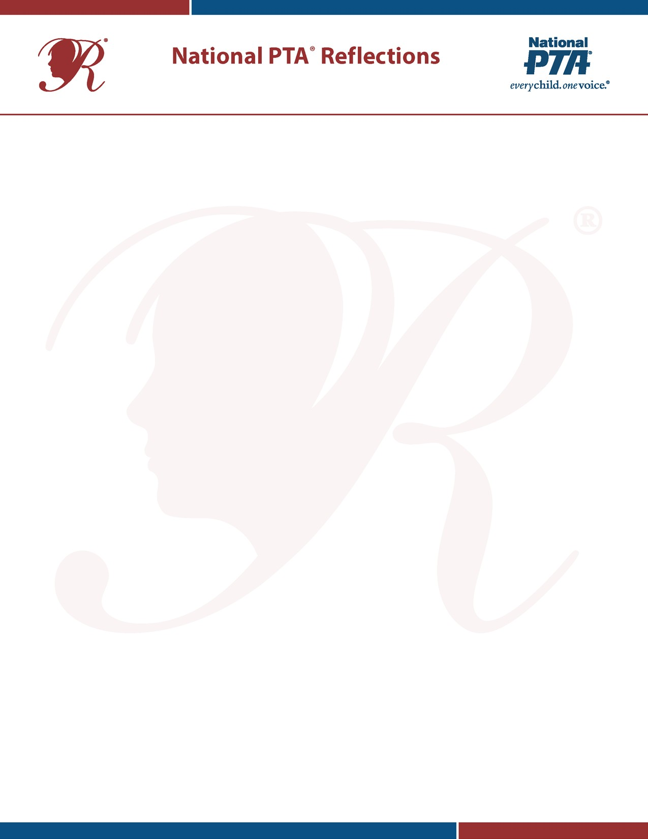
General Rules for Participation

All students must adhere to the General Student Participation Rules, as well as the rules for their specific arts category. Program rules and student entry forms are provided by your state PTA. To reference national rules, visit PTA.org/ReflectionsToolkit
Student Eligibility and Entry Guidelines: Students must participate in the National PTA Reflections program through a local PTA/PTSA in good standing, as determined by their state PTA. It is your Local PTA Reflections Committee’s responsibility to confirm that your PTA is in good standing and to determine each student’s eligibility. Questions about your student’s eligibility and/or your PTA’s good standing should be directed to unit President.
The following additional guidelines apply to student entries:
  - Each entry must be the original work of one student only.
  - A student may develop an entry inside or outside of the school.
  - A student may submit entries in more than one arts category.
  - Each student entry must be accompanied by a paper MANDATORY STUDENT ENTRY FORM which must be signed by the student and a parent or guardian.
  - Student entries must include a title and an artist statement, which communicates the artist’s inspiration for the work and how it relates to the theme. The statement must describe the content and include at least one sentence, but not exceed 100 words.
Students with Disabilities: Students with disabilities may participate in the National PTA Reflections program in one of two ways.
- Enter in Special Artist Division to receive non-artistic accommodation and assistance from an adult. Students are recognized and awarded prizes as part of the Special Artist Division. The Special Artist Division is an optional division of the Reflections program, accepting students in all grades whose physical, cognitive or mental health challenges meet guidelines set forth in the Americans with Disabilities Act.
National PTA will honor one special artist from across all arts categories to receive an Outstanding Interpretation Award. Up to six additional special artists will receive a National PTA Award of Excellence.
- Enter in grade division most closely aligned to the student’s functional abilities. Students are recognized and awarded prizes as part of the general student population without regard to special needs or challenges. In this case, students follow all general rules and arts category rules but may submit their entries in the grade division most closely aligned to their cognitive or functional abilities.
Originality: Specific rules related to originality for each arts category are provided by your state PTA. National rules can be referenced at PTA.org/ReflectionsToolkit. In general:
  - An adult may not alter the creative integrity of a student’s work.
  - Only one student may be recognized for each entry; collaboration with other students is not allowed. Other individuals may appear in or perform a student’s work, but the work itself—the dance choreography, film production (i.e., screenplay, camera work and directing) or musical composition (i.e., written score and any lyrics)—must be the creative product of one student alone.

  - The artwork must be inspired by the current year’s theme and created expressly for the program. Artwork produced before the dissemination of the theme or used for another competition or program may not be submitted.
Use of Copyrighted Materials: Use of copyrighted material is prohibited in the literature, music composition, photography and visual arts categories. This includes the use of copyrighted cartoon characters, copyrighted material from the Internet, advertisements or advertising ideas, musical themes from existing copyrighted compositions, copyrighted recorded music, copyrighted photographs or stock images. Use of copyrighted music in dance choreography and film production entries is acceptable when the title, composer and performer of any music in the submission are cited on the student entry form.
Film productions, photography and visual art may include public places, well-known products, trademarks or other copyrighted material, as long as that copyrighted material is incidental to the subject matter of the piece and is a smaller element of the whole. Visual arts collages may include portions of existing copyrighted works, such as portions of photos, magazine clippings, internet images and type cut out of a newspaper, as long as those pieces of copyrighted works are used to create a completely new and different work of art. A collage should be judged for its whole—not its parts—and its creativity as an original work of art. Misuse of the above materials constitutes plagiarism—taking and using another’s words, ideas or inventions as one’s own.
Addressing Student Ineligibility: Occasionally, entries submitted to the Reflections program are ineligible. One reason for ineligibility is that the local PTA is not in good standing. It is very important that you check with your PTA president to ensure your PTA is in good standing with the state. Other common reasons for ineligibility are plagiarism and resubmission. The following recommended procedures apply to both plagiarized and resubmitted entries:
- Scan entries to ensure that all are original and have not previously been submitted to Reflections or another art competition.
- Alert judges to the possibility that some pieces may not be original and encourage them to communicate when one may be questionable.
- Check questionable entries via Google or another search engine.
- Return ineligible pieces to students, and explain why they are being returned.
- Talk with appropriate school personnel, such as school counsellors, the principal or teachers about ways to address the seriousness of copying someone else’s work or resubmitting artwork with the student and his/her family.
If ineligibility is confirmed after judging, determine whether awards (including award money, pins, certificates, etc.) should be returned.

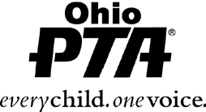
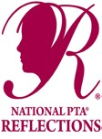
OHIO PTA REFLECTIONS PROGRAM
General Unit and Council Participation Rules PTAs and Students must adhere to the General Participation Rules

Eligibility of PTA Units and Councils
as well as the rules for their specific arts

2009–2009 PTA Reflections® Program
- PTA’s in good standing with membership dues paid to OHIO PTA by November 30, 2021 may participate. Reflections chairman need to verify.

Number of Entries - Councils need to check how many units are in your council
- Council with 3 - 15 PTA units may submit up to 28 entries to Ohio PTA
- Council with 16 - 39 PTA units may submit up to 60 entries to the Ohio PTA
- Council with 40 or more PTA units may submit up to 76 entries to Ohio PTA

Others
- Non-council Units may submit up to 16 entries to Ohio PTA
- Community PTAs (per bylaws) may submit up to 28 entries to Ohio PTA
- Units whose council does not participate may submit up to 16 entries to Ohio PTA

REQUIREMENTS
Every participating PTA unit and council MUST complete an online registration process.

Every winning student’s entry MUST complete an online Student Entry Form.

Every Student must fill out a paper hard copy of the 2021-2022 Mandatory Student Entry Form, recommend form is typed and must be attached to each individual Reflections entry
  - All lines must be complete and filled in with appropriate information
  - ALL PARTICIPATING STUDENTS MUST SIGN THE MANDATORY STUDENT ENTRY FORM

A PARENT OR GUARDIAN MUST ALSO SIGN THE MANDATORY STUDENT ENTRY FORM for all children under 18 and for all children with Special Needs
  - The Local Unit Information must be filled out entirely. Recommend Reflection Chair completes

Submit the MANDATORY OFFICIAL OHIO PTA PARTICIPATION FORM with entries mailed to the Ohio PTA Office. Forms must be complete with ALL information or entries will not be accepted.

___ All entries submitted via flash drive or disk must be separated by both age and art category

The Official Reflections Entry Deadline for submitting all Reflections entries and required paperwork to the Ohio PTA office is
WEDNESDAY, JANUARY 12, 2022 by 4:30 p.m.
There will be no exceptions to this Official Reflections Entry Deadline

Ohio PTA has a moral obligation to adhere to the rules set forth by National PTA and Ohio PTA. Failure to follow these rules will result in disqualification

Guide to Online Registration

PTA Registration & Reporting Instructions:
Verify your State PTA’s instructions before registering and reporting for your PTA.

NEED HELP?
For technical assistance, contact Info@PTA.org (800) 307-4PTA
- Register Your PTA from July 1—January 1 at PTA.org/Reflections.
  - Enter your National PTA 8-digit ID Number.
  - Enter your PTA Name, City, State, ZIP.
  - Enter your PTA Leader Name, Title, Address, City, State, ZIP.
  - Enter your School Name, Number of Students Enrolled, Title I
Status (Y/N), Percent of students who receive free/reduced priced lunches.
  - Enter your additional contacts who wish to receive program communications from State and National PTA.
  - Click “Submit” and receive a confirmation email.
- Report Student Participation & Program Success from September 1—March 1 at PTA.org/Reflections.
  - Enter your National PTA 8-digit ID Number.
  - Select which grade divisions your PTA offered.
  - For each division, Enter student participation totals for each arts category.
  - Enter total number of participating students.
  - Select true statements regarding your program’s success.
  - Click “Submit” and receive a confirmation email.

Student Entry Portal Instructions:

Create an Account.
Verify your State PTA’s instructions before using the Student Entry Portal.

NEED HELP?
For technical assistance, contact
support@myreviewroom.com
  - Visit PTA.org/Reflections and click the “Submit Student Entry” button.
  - Click “sign up” and enter your full name, email and create a password.
  - Click “register” and receive a confirmation email.
  - Click the unique link in your confirmation email to activate your account.

Submit Advancing Student Entries.
  - From your account’s home page, click “create a submission” for each student entry advancing to the next round.
  - Click “Student Entry Form” to enter Student Entry Information.
  - Click “Upload Artwork” to upload a digital copy of the entrant’s artwork (optional).
  - Click “submit your student entry” to submit student entry. If you submit a student entry by accident or need to make edits to completed forms, please notify your State PTA.

Confirm Student Submission Status.
  - From your account’s home page, view a list of created submissions. Confirmed submissions will show a status of “Submitted.”
  - Look for State and National PTA award announcements and special invitations to Reflections celebration events.

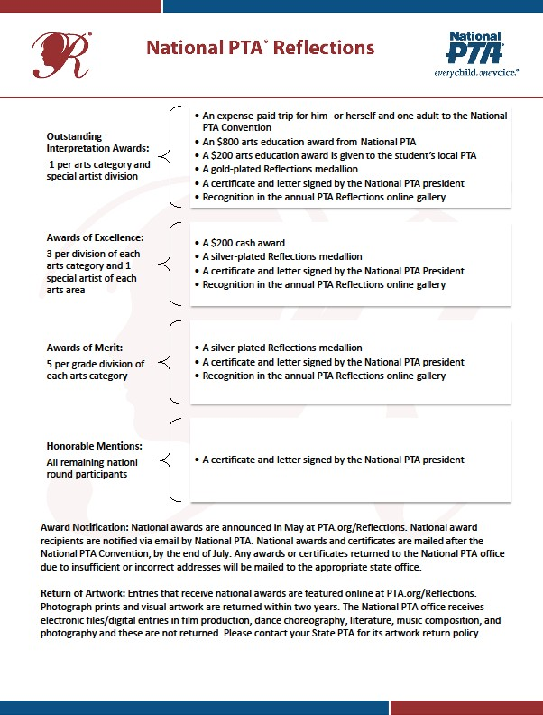
- Ohio PTA Awards include Award of Excellence, Award of Outstanding Achievement, Award of Merit and Honorable Mention in each age category for Visual Arts, Literature, Dance Choreography, Film Production, Musical Composition, Photography and Special Artist.
- Ohio PTA’s Visual and Photography artwork is returned to the local unit, except for those entries selected by Ohio PTA. Check with your District Advisor for specific return dates. The winning entries are returned to the local units. Literature, video, music and dance entries are not returned.
- Ohio PTA exhibits the winning entries at the annual Ohio PTA Convention and at various locations throughout the months of May-October.

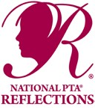
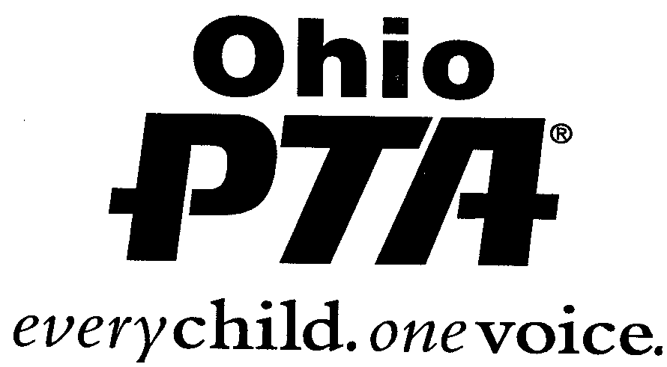
REFLECTIONS PROGRAM 2021-2022
“I Will Change The World By…”
OFFICIAL OHIO PTA PARTICIPATION FORM

Name of PTA__________________________________
Council Name__________________________________ Ohio PTA Region #_____________

Name of PTA Reflections® Chairperson__________________________________________
Chairperson’s Home Address
(Street) (City) (Zip)
Chairperson’s Home Phone _______________Chairperson‘s E-mail____________________________

ENTRIES SUBMITTED AS:
Non–Council Units & Unit Councils who do NOT participate: Limited to 16 eligible Number entered:
Community PTA: limited to 28 eligible Number entered:
Councils: 3 –15 units limited to 28 eligible Number entered:
16 – 39 units limited to 60 eligible Number entered:
40 or more units limited to 76 eligible Number entered:

CATEGORIES Total # Of Entries forwarded to Ohio PTA ____________

LITERATURE MUSICAL COMPOSITION
PHOTOGRAPHY

VISUAL ARTS

DANCE CHOREOGRAPHY FILM PRODUCTION

SPECIAL ARTIST: VA
Film
Photo Music DC Lit

Total Number of PTA Units Participating Total Number Sent

All entries and paperwork must be sent in together and preferably in one box.
A copy of this entry form must be included in each package of entries.
ALL ENTRIES MUST BE IN THE OHIO PTA OFFICE ON OR BEFORE WEDNESDAY, JANUARY 12, 2022 BY 4:30 P.M.
Send this form along with the entries to the
Ohio PTA at 40 Northwoods Blvd., Suite A, Columbus, OH 43235-4718

PHOTOGRAPHY
Color, Black and White
Single photo, panoramic, photomontage, a multiple exposure, negative sandwich or photogram.
No smaller than 3x5, No larger than 8x10 (11x14 with matting).No frames
No 3-D entries
No slides or transparencies
No collages or multiple photo

REFLECTIONS
At A GLANCE
PTA DUES MUST BE PAID TO OHIO PTA BY NOVEMBER 30, 2021

AGE CATEGORIES
Primary: Preschool – Grade 2
Intermediate: Grades 3-5
Middle: Grades 6 – 8
High School: Grades 9 – 12

All entries must be signed by student
and parent (unless over 18)
DANCE CHOREOGRAPHY
Original work of one student

Not to exceed 5 minutes
Credit music used

FORMAT

Video: AVI, MP4
Maximum Upload File Size: 1,000 MB

Record production on CD/DVD or flash drive

VISUAL ARTS
Architecture, carpentry, ceramics, collages, photographic collages, computer-generated image, crafts, design, dioramas, drawing, fiber work, jewelry , kites , metal etching/punch work , mobiles , painting, printmaking, sculpture , and windchimes.
Dimensions of 2D works not to exceed
24 x30 including matting
No frames
Mount 2D artwork on a sturdy backing

* 3D works. Must include three photos for each 3D entry. Do not send actual 3D works.

See Student’s packet for details.

MUSICAL COMPOSITION
Original Composition
Voice, instrument(s), or a combination of voice and instrument(s)

Not to exceed 5 minutes and 1000MB in file size

FORMAT
Audio Recording of Music Performance:
MP3, WAV

Record production on CD or flash drive
PDF of music notation is required for Middle and High School entries

FILM/VIDEO PRODUCTION

Animation Narrative
Documentary Experimental
Media presentations

Original work of one student

Not to exceed 5 minutes
Credit music used

FORMAT

Video: AVI, MP4
Maximum Upload File Size:
1,000 MB

Record production on DVD/CD
or flash drive

See www.ohiopta.org for more info

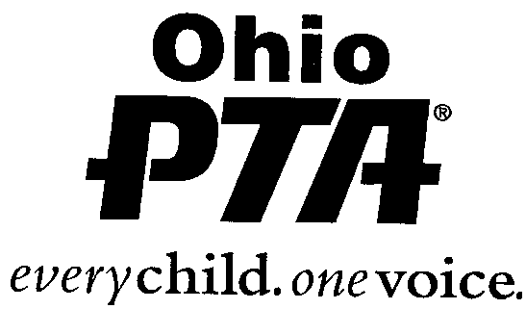

LITERATURE
Fiction or non-fiction
Prose, poetry, drama, reflective essay, narrative, short story

Do not exceed 2000 words

Grade appropriate grammar,
punctuation and spelling

FORMAT
Single-sided handwritten or typed on 8 ^{1/2} X11” paper
PDF

STATE DEADLINE:
January 12th, 2022
In office by 4:30 pm
Contact brandy@ohiopta.org in advance if dropping off in person

SPECIAL ARTIST

Disability as defined by Americans with Disability Act (ADA)

May enter in any category
See guidelines for Student Packet

Student Entry Form must be signed by parent/guardian regardless of age

